**INTRODUCTION:**

Theory Xilinx ISE(“Integrated Synthesis Environment”)Is a software tool developed by Xilinx for analysingand synthesizing “HDL” designs. This software enables designers to compile and simulate their designs and perform task like timing analysing and examining “RTL” diagrams.

Xilinx designs and develops programmable logic products, including integrated circuits (ICs), software design tools, predefined system functions delivered as intellectual property (IP) cores, design services, customer training, field engineering and technical support.

**OBJECTIVE:**

In this lab we are going to download and install Xilinx ISE design software. We will set up the software and try to understand it.

Step 1: Download the ISE setup.



Step 2: Extract the setup in a folder.

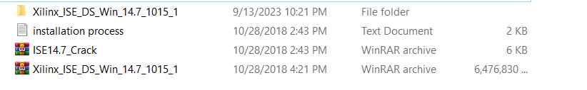

Step 3: Open setup and run as administrator.

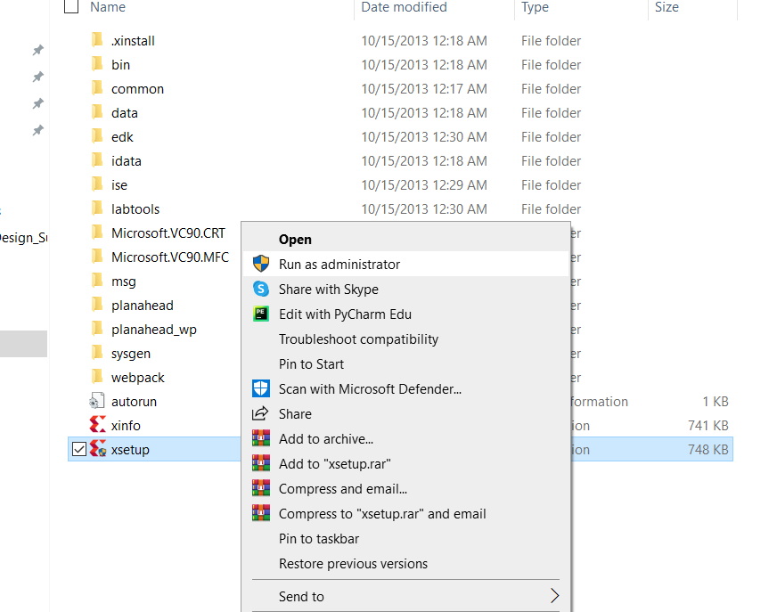

Step 4: Click next.

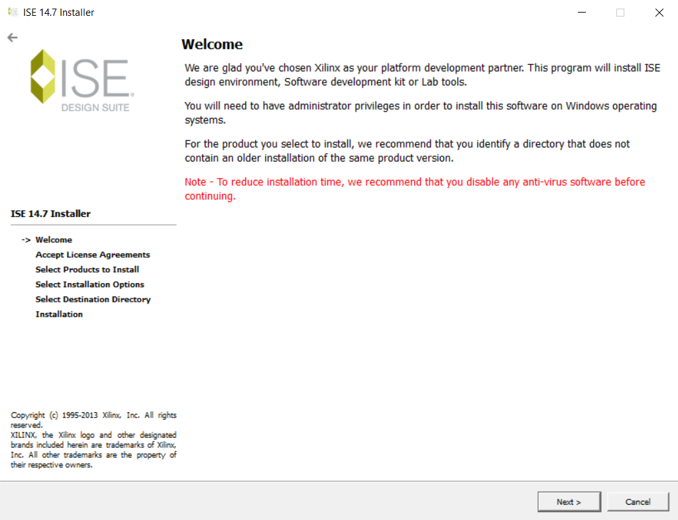

Step 5: click install.

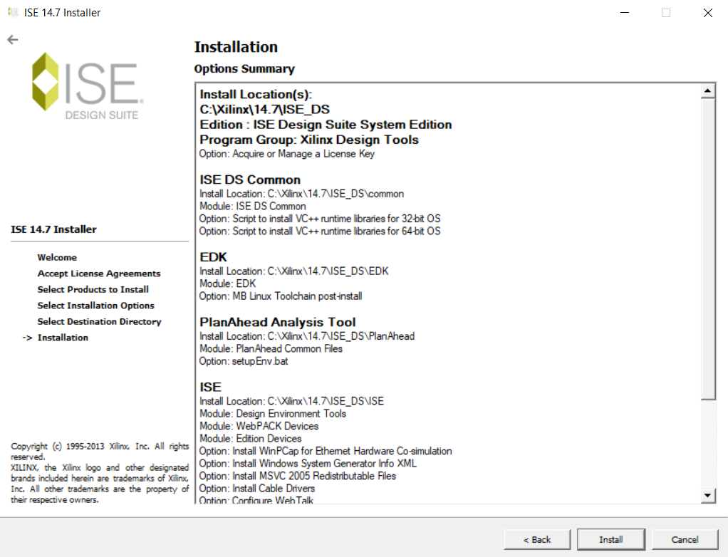

Step 6: Extracting.

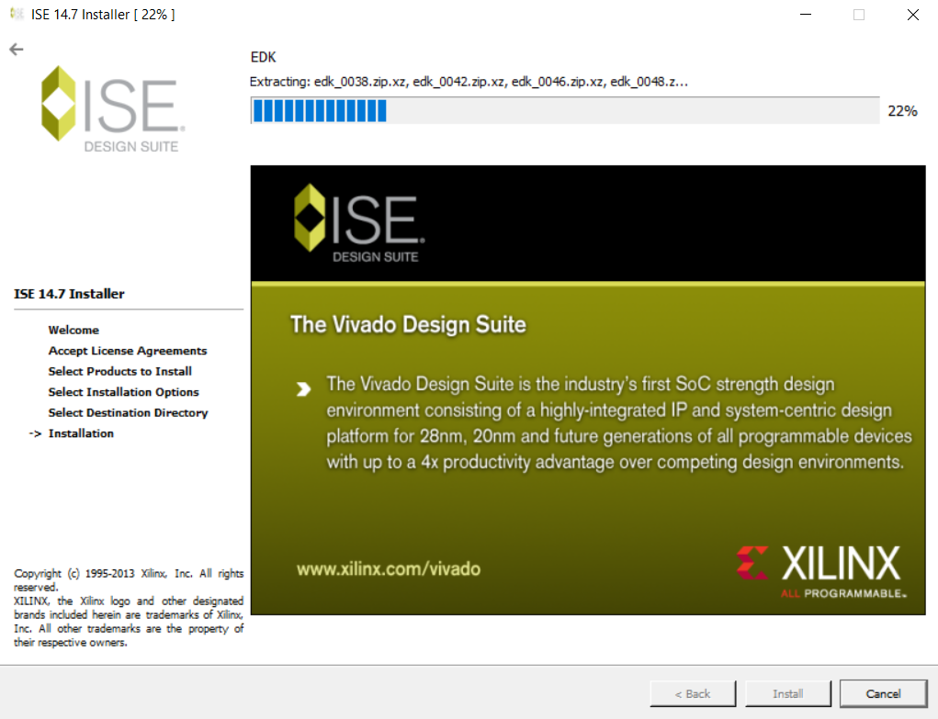

Step 7:

Install the components.

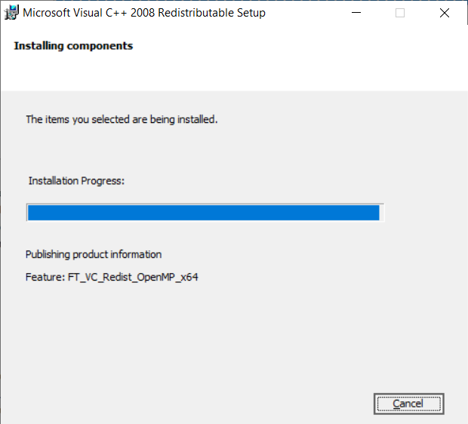

Step 8:Add License

